**Use instructions of Arduino IDE is shown in the following picture:**

1.Double click to open the Arduino software that is installed on the desktop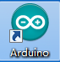.

2.In the menu bar of Arduino IDE，select the 【Tools】---【Board】--- 【Arduino Uno】.

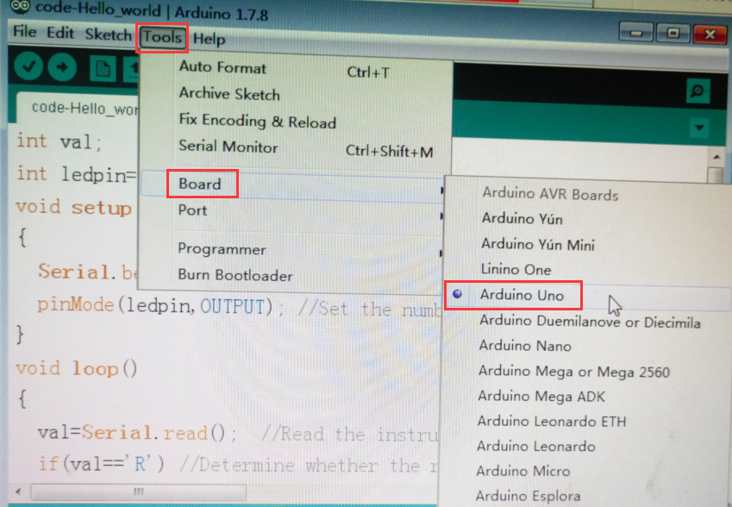

3.Connect the board and the computer ,select “Port”,marked with CH340 port,for example:USB-SERIAL CH340(COM6).

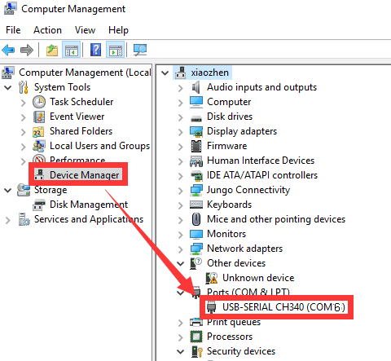

4.In the menu bar of Arduino IDE，select the 【Tools】---【Port】--- select the port that the serial number displayed by the device manager just now.for example:COM6.

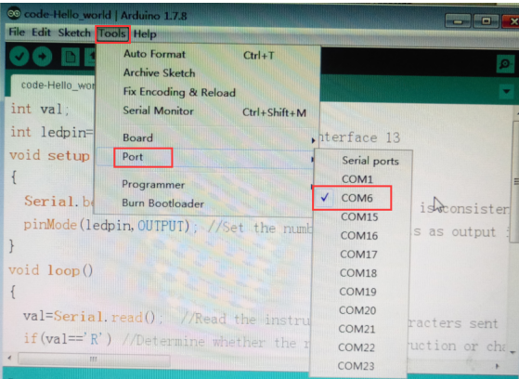

1. Write programs in the blank area (or directly open.ino suffix files)

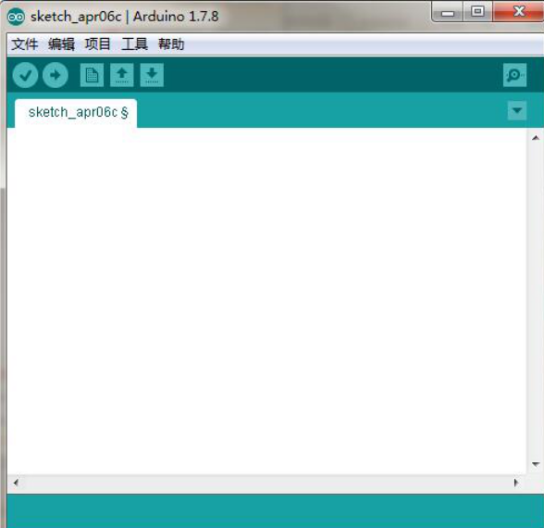

6.Click this button to complie

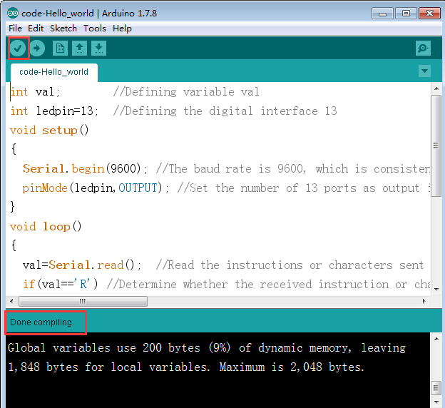

7.Click this button to upload

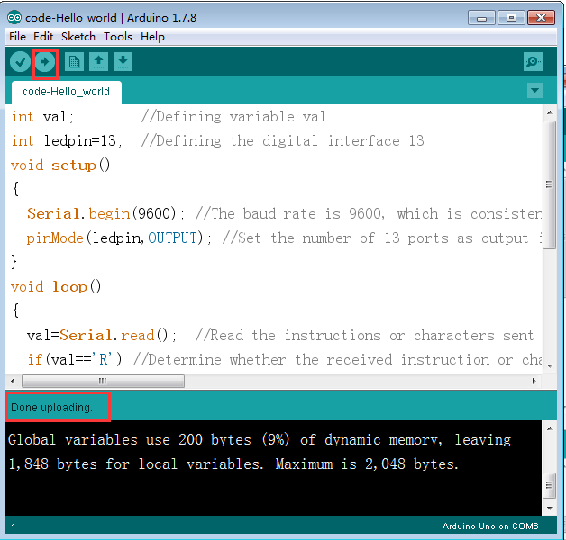

After these steps, the program is uploaded to the development board successfully.